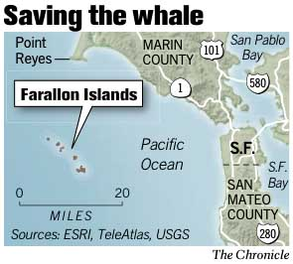
A humpback whale freed by divers from a tangle of crab trap lines near the Farallon Islands nudged its rescuers and flapped around in what marine experts said was, “…a rare and remarkable encounter.”
Daring Rescue of Whale off Farallones
Adapted from the December 14, 2005 article in The San Francisco Chronicle

"It felt to me like it was thanking us, knowing that it was free and that we had helped it," James Moskito, one of the rescue divers said. "It stopped about a foot away from me, pushed me around a little bit, and had some fun."
Sunday's daring rescue was the first successful attempt on the West Coast to free an entangled humpback whale, said Shelbi Stoudt, manager for the Marine Mammal Center in Marin County, California.
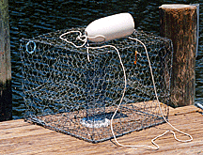
The approximately 50-foot female humpback, believed to weigh 50 tons, was on the humpbacks' usual migratory route between the Northern California coast and Baja California when it became caught in the nylon ropes that link crab pots.
It was spotted by a crab fisherman at 8:30 a.m. Sunday in the open water east of the Farallones, about 18 miles off the coast of San Francisco.
Mick Menigoz of Novato, who organizes whale watching expeditions, got a call for help Sunday morning. He then alerted the Marine Mammal Center and gathered a team of divers.
By 2:30 p.m., the rescuers had reached the whale and evaluated the situation. Team members realized the only way to save the endangered whale was to dive into the water. It was a very risky plan, Stoudt said, because the mere flip of a humpback's massive tail can kill a man.
"I was the first diver in the water, and my heart sank when I saw all the lines wrapped around it," said Moskito, who works with an adventure company. "I really didn't think we were going to be able to save it."
Moskito said about 20 crab-pot ropes, which are 240 feet long with weights every 60 feet, were wrapped around the animal. Rope was wrapped at least four times around the tail, the back and the left front flipper, and there was a line in the whale's mouth.
The crab pot lines were so tight, Moskito said, that the rope was digging into the animal's blubber and leaving visible cuts.
At least 12 crab traps, weighing 90 pounds each, hung off the whale, the divers said. The combined weight was pulling the whale downward, forcing it to struggle terribly to keep its blow- hole out of the water.
Moskito and three other divers spent about an hour cutting the ropes with a special curved knife. The whale floated passively in the water the whole time, he said, giving off a strange kind of trembling.
"When I was cutting the line going through the mouth, its eye was there winking at me, watching me," Moskito said. "It was a grand moment of my life."
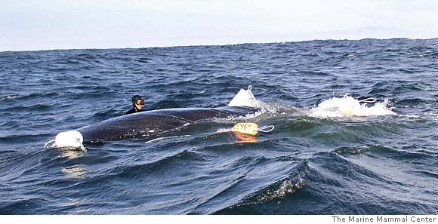
When the whale realized it was free, it began swimming around in circles, according to the rescuers. Moskito said it swam to each diver, nuzzled him and then swam to the next one.
"It seemed kind of affectionate, like a dog that's happy to see you,'' Moskito said. ”I never felt threatened. It was an amazing, unbelievable experience."
One of the divers on the rescue team works on the crab pot lines that held the whale. The weight of the crab pots was pulling the animal down. Marine Mammal Center photo via Associated Press

Whale experts say it's nice to think that the whale was thanking its rescuers, but nobody really knows what was on its mind.
Humpback Whales are characterized by:
- a flat head and
- flippers up to 15 feet long
- average 45 feet long
- black body, white black or mottled undersides
- white or black flippers
- a humped back in front of the dorsal fin
"You hate to humanize too much, but the whale was doing little dives and the guys were rubbing shoulders with it," Menigoz said. "I don't know for sure what it was thinking, but it's something that I will always remember. It was just too cool."
"You do hear reports of friendly humpbacks, whales approaching boaters, especially in Baja California," Stoudt said, "but, for the most part, they don't like to be interacted with."

